
MUUGLines
The Manitoba UNIX User Group Newsletter
Volume 32 No. 8, April 2020 Editor: Troy Denton, P.Eng
Next Meeting: Cancelled
In light of the current concerns over COVID-19 and the risk of infection, and in keeping with a directive from the University of Winnipeg (which states “All discretionary events on campus currently scheduled until May 1, 2020 will be postponed.”), the MUUG board has decided to cancel the April 14th meeting.
The board will be looking into ways we can provide a remote, virtual meeting for subsequent months, if the current public health circumstances continue. (Stay tuned for updates on future meetings.)
Linux Kernel 5.6 Released
Linus Torvalds announced the release of the 5.6 kernel on March 29. Notable features include built-in WireGuard VPN functionality, multi-path TCP, and initial USB4 support. There are numerous hardware support additions, and network driver fixes as well. You can check out the announcement at lkml.org:

https://lkml.org/lkml/2020/3/29/379
Open Source Teleconferencing: Jitsi
With social distancing measures in place, there has been a heightened demand for teleconference solutions. While there are many popular services (that even work with many desktop Linux distributions), you need not drain your wallet just yet: Jitsi has recently put together an overview of their open-source teleconference software. You can even test-drive their free service at https://meet.jit.si/:
“Jitsi Meet is a fully encrypted, 100% open source video conferencing solution that you can use all day, every day, for free – with no account needed.”
Jitsi is an open source project, and has been designed to be extensible and embeddable, to meet your organization’s needs.
You can learn more about Jitsi via their latest blog post.
https://jitsi.org/news/make-it-live-with-video/
LineageOS 17.1 Released
LineageOS – a free and open-source OS based on the Android mobile platform – has just announced the release of version 17.1. This release includes new features, such as a ‘partial screenshot’ UI, a new ‘ThemePicker’ app, and other improvements.

https://lineageos.org/Changelog-24/
3D Printing & Open Source
to the Rescue
“Makerspaces”, hobbyists, and tinkerers around the world have been helping healthcare providers overcome supply chain issues in their battle against COVID-19. Some efforts focus on reproducing existing ventilator parts via 3D printing, whereas other projects are working on entire open source ventilator designs.
Massimo Temporelli is one such enthusiast. Massimo was able to help 3D print 100 ventilator valves for a hospital in Brescia, Italy, when their supplier was unable to provide valves on short notice. You can read more about this lifesaving work at 3dprintingmedia.network.
One popular focal point for open source COVID-19 equipment is the “Open Source COVID19 Medical Supplies” group on facebook, where medical and technical experts are exchanging designs, information, and feedback.
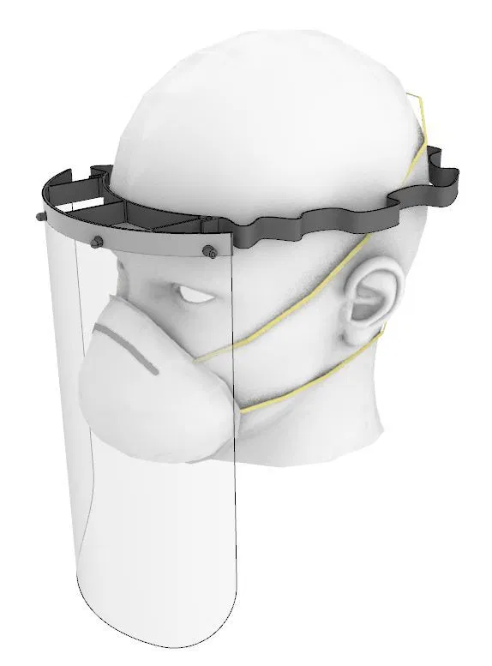
A faceshield design from faceshield.us
Other efforts for front-line health worker equipment include open source face shield designs, including the one depicted here, developed by
https://faceshield.us/.
Meanwhile, a team at MIT is giving a 10-year old project a breath of fresh air – the MIT E-Vent team have revitalized an old MIT ventilator project to help provide a low-cost, easily produced ventilator design. Development is active, and the team is seeking donations - their team mobilized too fast to secure any research funding! You can donate to the E-Vent team via this link.
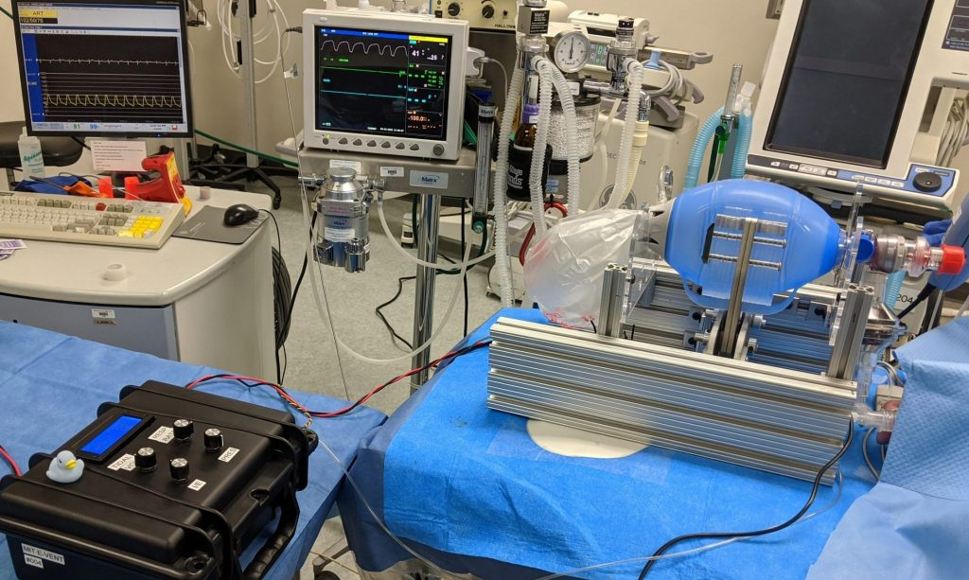MIT E-Vent Unit 002 Undergoing Testing, Image by MD

https://www.3dprintingmedia.network/covid-19-3d-printed-valve-for-reanimation-device/

https://faceshield.us/

https://www.facebook.com/groups/opensourcecovid19medicalsupplies/

https://e-vent.mit.edu/

http://news.mit.edu/2020/ventilator-covid-deployment-open-source-low-cost-0326

https://giving.mit.edu/give/to?fundId=3887150&source=WBMPP
COVID-19 Stress Tests the “Cloud”
Interconnected founder Kevin Xu has been busy analysing usage trends among popular cloud infrastructure providers. Kevin’s research highlights recent issues with Microsoft’s services, as well as their Azure cloud platform. Kevin also indicates that their communication of these issues also leaves something to be desired.
From Kevin’s article:
[...] in March alone, multiple issues have occurred on various Microsoft cloud services: twice in just the last few weeks for European users of Teams, customers not getting the capacity they need in the US East Region, and XBox Live going down during a time when online gaming is surely surging. To put the timing in perspective, America and Europe only started taking COVID-19 seriously on a societal level in March. Parts of Azure began to fail almost as soon as people’s behaviors began to change.
Conversely, Kevin is quick to point out that an absence of reported issues with AWS and many of their high-profile customers (including Netflix) is a sure sign of a superior service offering.

https://interconnected.blog/covid-19-stress-tests-cloud-azure-aws/
Computer Chips: Now With
Brainy Bits
Cortical Labs – a new biotech startup in Melbourne, Australia, is trying to change the way we think about computer chips – or more accurately, they trying to change the way chips think entirely!
From their blog:
Our vision, based on Karl Friston’s free energy principle, is to build technology that harnesses the power of synthetic biology and the full potential of the human brain to develop a new class of artificial intelligence with the fluid intelligence to adapt and problem solve for society’s greatest challenges.
According to fortune.com, Cortical Labs uses mouse neurons in it’s computer chip products, with their novel ‘Perfusion Circuit’ apparatus.
An XFCE user’s depiction of Cortical hardware

Keep your neurons focused on https://corticallabs.com/ for more of their wild ideas.

https://fortune.com/2020/03/30/startup-human-neurons-computer-chips/
FCC Mandates Caller ID Authentication
The FCC has adopted new rules requiring telecommunication service providers (TSPs) to implement new standards known as “STIR/SHAKEN”. These measures are designed to stop illegal caller ID spoofing.
The new order requires TSPs operating in the United States to employ STIR/SHAKEN on their IP networks by June 30, 2021.
In 2019, The CRTC – a similar regulatory body in Canada – concluded that TSPs “should be able to complete the implementation [...] by no later than 30 September 2020”.
With any luck this legislation will leave “robocall” and scam “CRA” operators SHAKEN in their boots!
https://docs.fcc.gov/public/attachments/DOC-363399A1.pdf
https://crtc.gc.ca/eng/archive/2019/2019-402.htm

New Linux Laptop Promises You can “Write code in VIM for 21 hours straight”
Linux-focused computer vendor System76 has announced the latest addition to their line of premium laptops: the Lemur Pro.
The System76 Lemur Pro
Users who have suffered from poor battery performance on previous System76 models will be pleased to hear that the Lemur Pro boasts a battery life of “up to 21 hours” between charges.
This exciting new model features a 10th gen Intel CPU, USB-C charging, a 1080p matte display, and up to 40GB of DDR4 RAM. Security-conscious consumers will also appreciate it’s open source BIOS firmware
The Lemur Pro is expected to arrive in early April, and comes pre-installed with a selection of Pop!_OS 19.10, Pop!_OS 18.04 LTS, or Ubuntu 18.04 LTS.

https://system76.com/laptops/lemur

https://github.com/system76/firmware-open
File Event Processing: incron
Have you ever written a cron job that repeatedly checks a directory for new files – an rsync job, or a post-processing job? Incron might be a valuable new addition to your sysadmin toolbox!
Incrond works in a way similar to crond. Instead of following a time schedule, it uses inotify features to run commands based on the events in a file’s lifecycle. These inotify events cover cases like: “a new file was opened for writing in this directory”, or “file /foo/bar.baz was written to”.
Here’s an example: whenever a file finishes uploading to /var/upload, we want to move it to /var/hold. With incron installed, you could use the following configuration in /etc/incron.d/uploads.conf:
/var/upload IN_CLOSE_WRITE mv $@/$# /var/hold
/var/upload is the directory to watch, IN_CLOSE_WRITE is the event to watch for (i.e. when a file is closed after writing to it), and the rest of the line is the command to run. $@ gets replaced with the watched directory, and $# is replaced with the event-related filename.
Don’t let this simple example fool you – this has lots of potential uses. But, Debian 10 users beware – there is a known bug where user incron jobs can result in zombie processes, and/or extra incrond processes. You can easily install incrond from source to avoid this – I have a patched version available here:
https://github.com/trdenton/incron
Thank You, LES.net
A big thanks to Les.net for providing MUUG with free hosting and all that bandwidth! Les.net (1996) Inc., a local provider of VoIP, Internet and Data Centre services, has offered to provide a 10% discount on recurring monthly services to MUUG members. Contact sales@les.net by email, or +1 (204) 944-0009 by phone, for details.


https://les.net/
$1,000 Worth of Free Credit Card Processing!

Ever wanted to start accepting credit cards for your own needs?
Now it’s FREE!
Sign up with Square (the credit card processor that MUUG uses at our monthly meetings) with the referral link below and both you and MUUG will receive $1,000 in free processing for the next 6 months (180 days).
You must use the following referral link for MUUG to receive the credit:

https://squareup.com/i/MANITOBAU1

Creative Commons License

Except where otherwise noted, all content in this newsletter is licensed under a Creative Commons “Attribution-ShareAlike 2.5 Canada” License.
http://creativecommons.org/licenses/by-sa/2.5/ca/deed.en_CA

XKCD: Cron Mail
https://xkcd.com/1728/

