
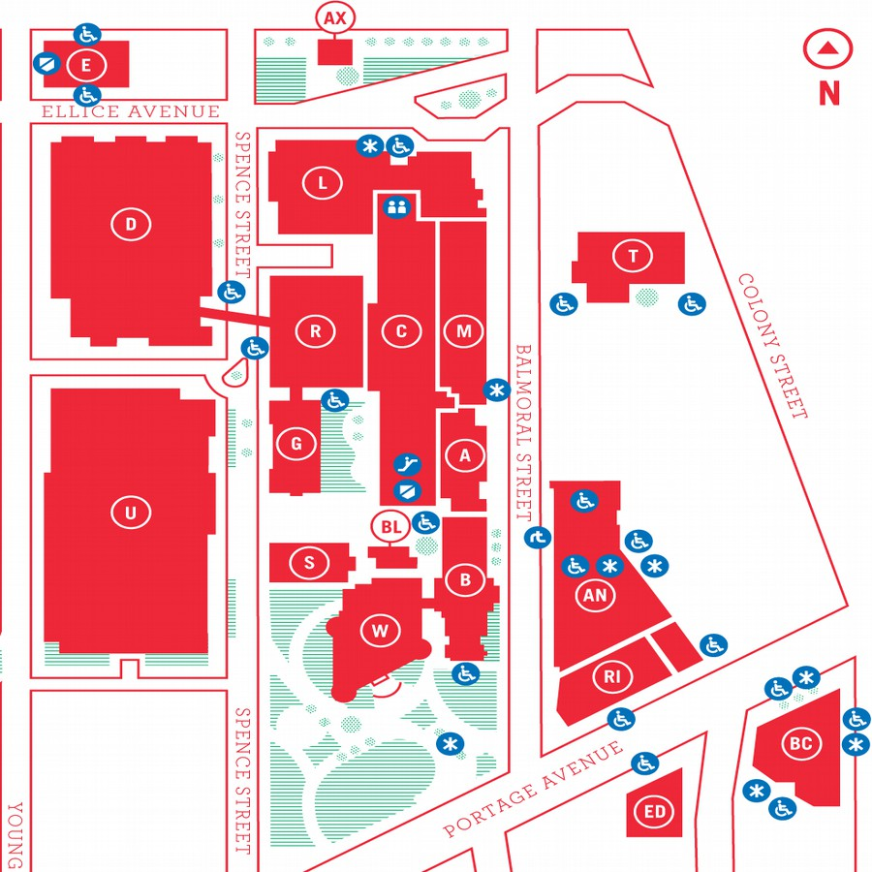
MUUGLines
The Manitoba UNIX User Group Newsletter
Volume 28 No. 7, March 2016 Editor: Wyatt Zacharias
Next Meeting: March 8th, 2016, 7:30pm

Main Topic: Thunderbird

Brad Vokey will be doing a presentation on Thunderbird, a free, open source, cross platform email, news, and chat client developed by the Mozilla Foundation.
Brad will focus on how to customize Thunderbird with extensions (and other little known features) to take this email client into power user territory.
Topics will include the extensions: Keyconfig, Nostalgy, QuickFolders, Quicktext Pro, Signature Switch, Xnote, and Expression Search. He will also briefly cover tags, message filters, search folders, and other built-in tricks to help reduce the time you have to spend on email each day.

New Segment: Daemon-Dash
MUUG is proud to announce a new segment that has been dubbed: Daemon-Dash. The idea behind Daemon-Dash is to have a quick 15-25 minute presentation on a daemon, and dive right into the meat of the content. DD’s will forgo the usual introductory theory and use cases, instead showing users how to start using the daemon right away.

Daemon-Dash: dnsmasq
For our first ever Daemon-Dash segment, Paul Sierks will be presenting dnsmasq. Geared towards small networks, Dnsmasq provides DHCP, DNS, and TFTP services. Written in C, it features a small CPU & memory footprint making it suitable to run on just about anything, such as a home router. It has been adopted by some distributions which have it configured as a DNS cache. Other use cases include BOOTP and PXE network booting.
Where to Find the Meeting

New Room! 3M60 Manitoba Hall
New room! This month's meeting is on the east side of campus in room 3M60, 3rd floor, Manitoba Hall, close to Balmoral Street. Look for a sign on the door. There are elevators and escalators scattered around the buildings. A convenient one might be the elevator located right at the Ellice Ave entrance. Doors are usually open by 7:00 pm with the meeting starting at 7:30 pm. Parking is available on the surrounding streets. Please see http://www.uwinnipeg.ca/maps for further information about parking and access to the campus.
The latest meeting details are always at:

https://www.muug.mb.ca/meetings/
Door Prize
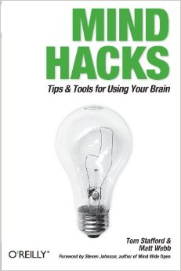
This month we (really!) will be giving away the O'Reilly book: Mind Hacks by Tom Stafford & Matt Webb.
Mind Hacks explores the abilities of the human brain, and explains some tips and tricks to explore the capabilities of the mind.

MUUG Survey
Attention all members! The MUUG board wants your opinion. Do you enjoy the presentations? What are we not presenting enough of? Do you like the location? Hate the pop? We want to know! So to help you answer these questions we've put together an online survey and we'd love it if every member would take the time to give us some feedback. The link for survey is located below, and if you're reading this in the paper newsletter, don't worry, we've sent a link to your inbox too.

http://fluidsurveys.com/surveys/matchomatics/muug-survey/
OpenSSH MITM Bug Discovered

Since version 5.4 (released March 8th 2010), the OpenSSH client has contained an undocumented feature called roaming. If the connection to a server breaks, but both the client and server have roaming enabled, the connection can be reestablished and the session will continue. Although roaming is not supported in OpenSSH Server, it is enabled by default on the client, and contains two vulnerabilities, an information leak and a buffer overflow.
The information leak vulnerability is exploitable with OpenSSH having its default configuration, with the use of a MITM attack, or connection to a compromised server. The information leak can allow private keys to be obtained from the client that is connecting.

https://goo.gl/hib4zO
Appeals Court Overturns Jury Ruling, Invalidates Slide-to-Unlock Patent
The Court of Appeals for the Federal Circuit (CAFC) has ruled in Samsung's favour on several appealed cases of patent infringement, where Samsung had previously been found by a jury to be infringing on several of Apple's smartphone patents, among them the dubious Slide-to-Unlock patent (US patent: 8046721) previously held as valid by Apple.
On the Slide-to-Unlock patent, the court said it was invalidated due to obviousness and the fact that all of the elements involved in the Slide-to-Unlock functionality were found in previous art. It notes that the “case for obviousness was strong” while “Apple's evidence... was weak”. In fact, the court is not at all impressed by Apple's arguments for why “slide to unlock” was some great innovation -- including the idea that because the Steve Jobs reality distortion field made people all excited about it, that doesn't mean the idea wasn't obvious at the time.
Apple appears to identify the unsolved problem as the lack of an “intuitive” method of unlocking a touch-screen portable device. But Apple provided no evidence showing that this problem was recognized in the industry. No reasonable jury could find testimony by a single expert about his personal experience with one device as evidence of an industry-wide long-felt need.
[....]
As evidence of industry praise, Apple presented expert testimony that the attendees at an Apple event manifested approval when Steve Jobs first presented and unlocked the iPhone.... Evidence of approval by Apple fans—who may or may not have been skilled in the art—during the presentation of the iPhone is not legally sufficient.
Additionally the court found Apple's autocorrect patent (US patent: 8074172) to be invalid, and found that Samsung was in fact not infringing on patent 5946647 which describes “systems and methods for performing an action on a structure in computer-generated data”.
Apple was originally awarded $120 million in damages from the 3 infringements, which Samsung will now not have to pay.

https://goo.gl/Bnxf6e
Intel Re-Locking Skylake CPUs With Unintentionally Unlocked Multipliers
Intel will shortly be releasing a microcode update for its Skylake series of processors in order to fix an unintended side effect allowing users with certain chipsets to adjust the clock-speed multiplier of their Skylake CPUs, even CPUs that are not part of the “K” line that intentionally allows the multiplier to be changed. Normally the ability to adjust the clock-speed multiplier is considered a premium feature, and consumers who want the feature must pay the price premium associated with it, so it's no surprise that Intel would want to put a stop to users having too much freedom with hardware that they've bought and paid for.
For most users though, the patch may be easy enough to avoid since the microcode update will come as a BIOS update issued by the manufacturers of the motherboards. Users who choose not to apply the new BIOS should remain able to change their multipliers.

http://goo.gl/iYMeR3
Gravitational Waves Discovered from Colliding Black Holes
Scientists from the Laser Interferometer Gravitational-Wave Observatory (LIGO) have recently held a press conference announcing their success in detecting gravitational waves from two black holes colliding deep in space.
Gravitational waves were first predicted by Albert Einstein in 1916 based on theory of general relativity, but even Einstein himself was unsure whether or not they truly existed. Scientists have been trying to detect gravitational waves since the 1960s but none have been successful until now.
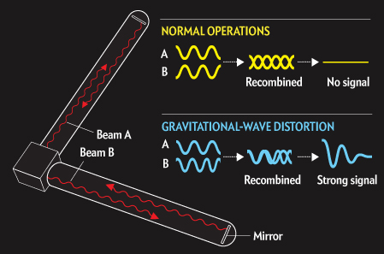
The LIGO project involves more than 1000 people, and has more than $1-billion in funding from the National Science Foundation. The project uses two detectors, one located in Washington State, the other in Louisiana designed to detect distortions in space that occur when a gravitational wave passes through earth. Each detector is shaped like a large “L” with laser light bouncing off mirrors and travelling the length of the legs of the L. When a gravitational wave passes through, infinitesimally small changes occur in the ground that is supporting the apparatus changing the distance that the laser beam travels. Paired with extremely accurate atomic clocks the laser emitters can detect the change in distance caused by the gravitational waves.

http://goo.gl/lTKyz3
Mercedes Replacing Robots with Humans on Assembly Lines
Yes you're reading that right, Mercedes has announced its plans to replace a number of assembly robots at its Sindelfingen plant with Human workers. Markus Shaefur, head of production at Mercedes-Benz explained “Robots can't deal with the degree of individualization and the many variants that we have today”.
Schaefer said the idea is to reduce the time spent to produce a car to just 30 hours, almost 50% less than the 61 hours that was standard in 2005. To facilitate the new human workers, Mercedes is developing a concept called “robot farming” where each worker is equipped with a set of smaller and lighter tools to be used in the assembly process. Mercedes competitors Audi and BMW are also rumoured to be conducting tests on the viability of replacing robots with more flexible human workers.

http://goo.gl/3ajLdM
ReactOS 0.4.0 Released

Zilang Guo has announced the release of ReactOS 0.4.0 the built-from-scratch operating system that aims to clone the design of the Windows NT architecture. ReactOS does not follow the UNIX like architecture of other Linux distros, instead its goal is to be binary compatible with Microsoft Windows, allowing drivers and other binaries designed for use by Windows to be used by ReactOS. Version 0.4.0 brings USB and wireless network support to the OS.

http://goo.gl/0fMoCG
RaspBSD: BSD on Raspberry Pi
Want to easily run BSD on the Pi? RaspBSD gives you an easy way to run FreeBSD 11 on it.

http://raspbsd.org/
Canadian Upload Speeds Suck
by Trevor Cordes
No, it’s not just you: your internet upload speeds are lame. In a slightly older news article, CBC investigates how we fare compared to the rest of world. It’s not pretty. Canada is 53rd in the list of countries ranked by upload speed. We’re 45% slower than the G8 average. And we pay more for our piddly pipes.

http://tinyurl.com/ofxn6ox
Star Wars Scroller in CSS3
For this month’s Waste-Of-Time segment, here’s a way to recreate the famous Star Wars scrolly text effect purely in CSS3! No javascript!

http://codepen.io/thatbram/pen/KuHsl
Perl Flip-Flop Op
by Trevor Cordes
File under “that’s handy”: Perl has an operator that acts like a flip-flop: .. (two dots). (Not to be confused with the .. (two dots) range operator. This is Perl, after all.) From the man page:
It is false as long as its left operand is false. Once the left operand is true, the range operator stays true until the right operand is true, AFTER which the range operator becomes false again.
Confused? Forget the definition, let’s just say it emulates the sed/awk line-range comma operator, and it’s very handy like this:
perl -ne ‘print if /^\s*$/../^--/’

That will print the body of an email, minus the header, minus the signature. And the flip-flop even remembers its state, per instance, outside and across subroutine calls!
Member Spotlight
by Trevor Cordes
Did you know one of MUUG’s members is a movie star who has appeared in over 30 films, shorts and TV movies, including Curse Of Chucky? Tyhr Trubiak is his name, and one of his movies – Aegri Somnia – where he plays the lead role, is (legally!) available for online viewing at the link below. Since it’s filmed in Winnipeg you can play spot-the-location. It’s far better than IMDB gives it credit, but you may have to watch a fair bit to really get into it.
And please, when in his presence, refrain from groupie activities like irrational screaming, tearing of clothes, and cutting of locks of hair. Also, any paparazzi will be removed from the premises.
Viewer discretion is strongly advised (violence, gore, sexual themes, nudity). Flash and javascript required.

http://tinyurl.com/jlnblqk
Creative Commons License

Except where otherwise noted, all content in this newsletter is licensed under a Creative Commons “Attribution-ShareAlike 2.5 Canada” License.
http://creativecommons.org/licenses/by-sa/2.5/ca/deed.en_CA

